Helping Missionaries and Churches reach the world for Christ

May God richly bless you!

**To learn more, go to www.australia.yomteams.com**

YOM Summer Mission Team to the country of the





Philippines

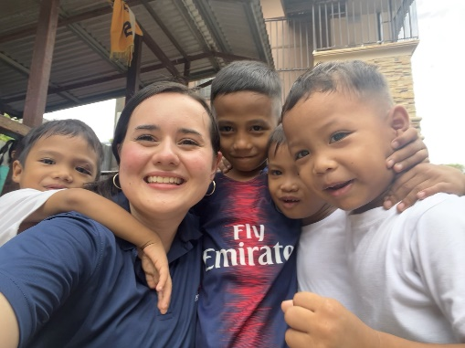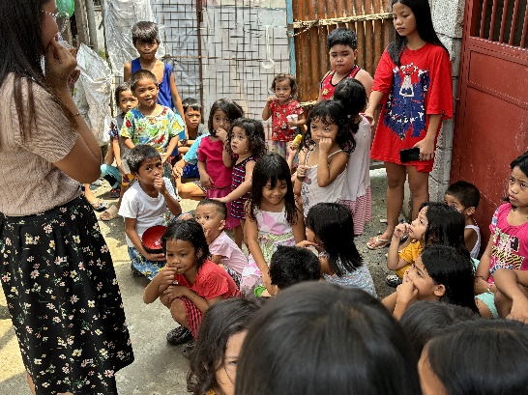

March 2025

Dear

Trust you are doing well as I just finish up with Bible Conference and am about to take my Midsemester Exams at Pensacola Christian College. Besides having had several opportunities to be involved in both academic and extra-curricular activities, I’ve been preparing for my upcoming missions trip to Australia. Though it has been a very busy semester, God’s grace and strength has been very evident!

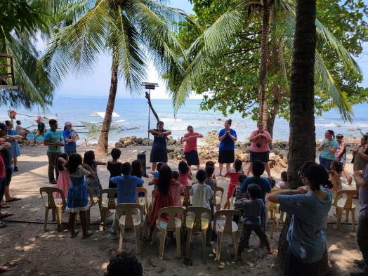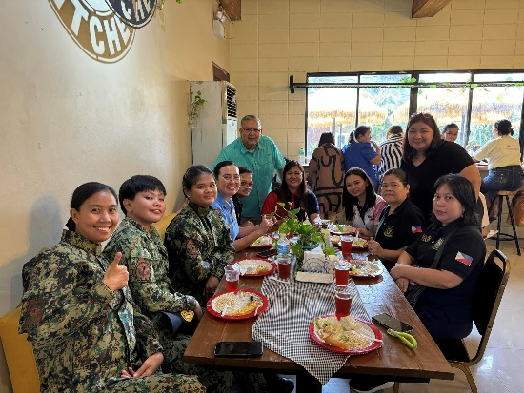

**With the cost of my trip being $3,000** (*plus additional monies needed for my personal flight to Los Angeles*), **God has wonderfully provided over $1,975**. The donations that I have received will help cover my Los Angeles to the Philippines (and return) airline ticket as well as accommodations, food, and needed supplies while serving in the Philippines.

**I would love to have your continued prayers** as we are praying that God would do a great work. Also, could you pray that the rest of my support would come in by the May 1st donation deadline?

If you feel led to donate, you could either make a check payable to *Youth Outreach Ministry* (YOM) and mail it to the address below, donate online, or donate using the provided QR code.

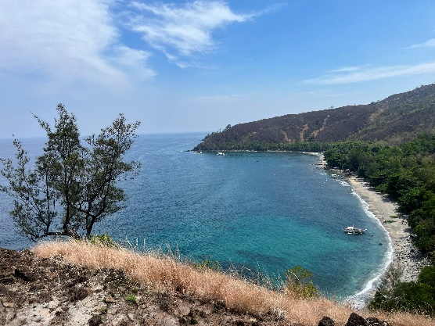

**Alyssa Savage**

Thank you for your continued prayers as I am so looking forward to this opportunity!

God bless,

**Sponsored by**

**To learn about Team Philippines,  
scan the QR code or go to** https://philippines.yomteams.com/

*If I receive more than the minimum funding of my portion of the cost of the trip, the extra money raised may go to the general expenses of the team, and any contingencies that may arise.

**I will be leaving for the Philippines on May 21** (returning on June 16) **and assist 7 missionaries and 10+ churches.** My ministries include preaching (men), teaching (ladies), music, testimonies, Bible Clubs/feedings, medical clinics, youth rallies, jail ministry, school outreach, orphanages, conferences, police/military ministry, music ministries, and cemetery/homeless outreach.

P.O. Box 18315,  
Pensacola, FL 32523

Phone: 850.430.9772

Website: https://yomteams.com/

**To donate, scan the QR code or go to**

https://yomteams.com/db/Donate2.php

*If I receive more than the minimum funding of my portion of the cost of the trip, the extra money raised may go to the general expenses of the team, and any contingencies that may arise.

P.O. Box 18315, Pensacola, FL 32523

Phone: 850.430.9772

Website: https://yomteams.com/

*If I receive more than the minimum funding of my portion of the cost of the trip, the extra money raised may go to the general expenses of the team, and any contingencies that may arise.