
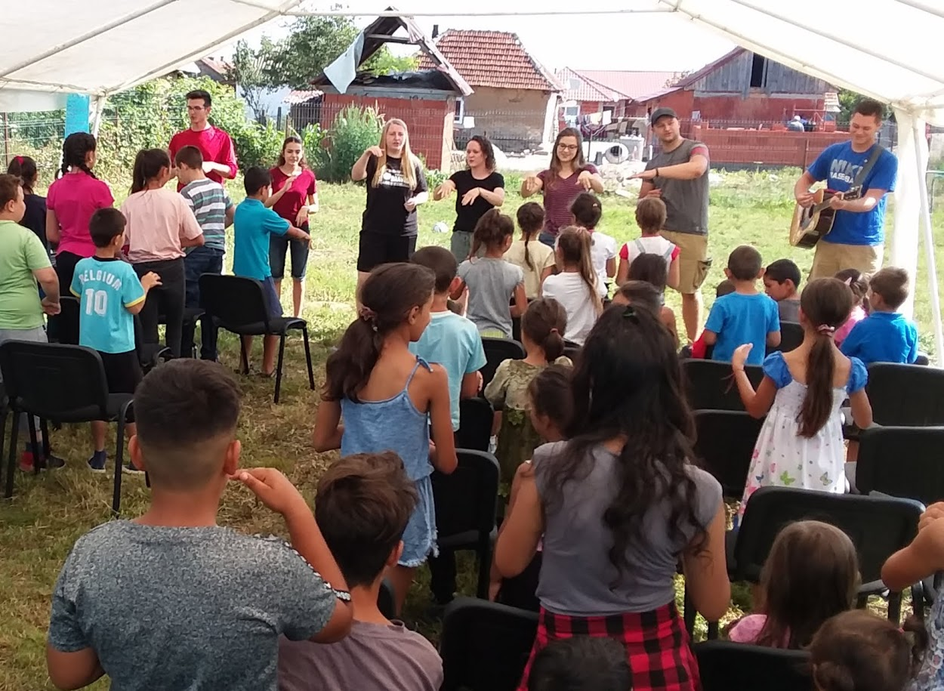
YOM Summer Mission Team to
Romania
“But ye shall receive power, after that the Holy Ghost has come upon you and ye shall be witnesses unto me both in Jerusalem and in Judea and in all Samaria unto the utter most parts of the earth.” Acts 1:8
Dear Friends and Family,

The Lord has recently opened some exciting opportunities for me that I would like to share with you.

Recently, I signed up with many other College Students requesting to be considered for the Y.O.M. Summer Mission Teams to Romania. I rejoice that God has allowed me to have been selected to be part of this mission’s team.

Our team will work with Ruben & Jordan Cristinoiu for our first week. You’ll get to teach Bible lessons, help in prayer groups, give personal testimonies, and coordinate activities and game time.

During the second week, our team will work with Brent and Sara George to minister to the Gypsy villages. We’ll host a youth outreach activity and help with village church ministries.

We look forward to serving in:
Tract & Bible distribution
Evangelistic Outreaches
Bible Clubs, Orphanages & Schools
All church services
Preaching, teaching, singing, puppets,
Youth Ministries & Visitation
Manual labor
& any area needed!

Pray with us for souls to be saved and for national believers to be encouraged.

Would you consider being a part of this ministry with me?

First and foremost, I ask for your prayers. Please pray that God will prepare us and supply our physical and financial needs.
Next, since this is a mission outreach, I must raise support. If you would like to help, the cost of the trip is $3,300 per person. The money will go toward the airline ticket, meals, Bible/tracts, accommodations, missionary needs, etc. Would you prayerfully consider helping in any way as we go forth to spread the GOOD NEWS of Salvation?

Please donate online, using the QR code or make checks payable to YOM It will be deposited into my individual account. YOM will, in turn, send you a receipt for your tax-deductible donation.

My first deadline in raising my support is February 1st. The final deadline for all donations is March 24. I am excited about this opportunity to serve. After our return in July, I will send a letter sharing how the Lord blessed.

Thank you in advance for your prayers and support. May God richly bless you!
July 4, 2025
through
July 19, 2025
Support to be raised:
$3,300*
Visit: www.YOMteams.com/Donate to give online

Helping Churches and Missionaries reach the world for Christ
P.O. Box 18315
Pensacola, FL 32523
phone: 850.430.9772
Email: director@yomteams.com

Please Note: If I receive more than the minimum funding for my portion of the cost of the trip, the extra money raised may go to the general expenses of the team and any contingencies that may arise.
Sponsored by YOM Teams
Signature

