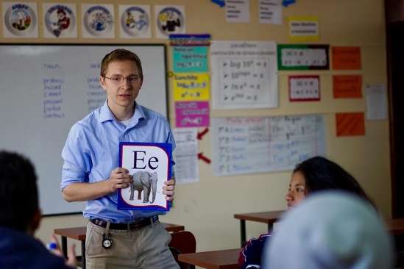[GiveButton](https://yomteams.org/donate/)

Please Note: If I receive more than the minimum funding for my portion of the cost of the trip, the extra money raised may go to the general expenses of the team and any contingencies that may arise.

**Donate**

**online at**

[**yomteams.com/donate**](https://yomteams.com/donate/)

The dates for the trip are **May 23rd through June 6th.** Our desire is to be an encouragement and blessing to the people of Ecuador as we seek to see souls saved.

The goal of our Ecuador team is to proclaim the gospel of Christ, train believers in His ways, and further His kingdom. You’ll get to help with camps, conferences, and other ministries.

Additionally, our team will use Abeka’s ESL to share verses and the gospel with the children of Ecuador and the Galapagos. We also hope to do a creation **seminar in the Galapagos.**

Print your name here.

**Sign name here**

**Support to be raised:** $2,700

P.O. Box 18315

Pensacola, FL 32523

phone: 850.430.9772

Dear [Enter name of prospective supporter]

The Lord has recently opened some exciting opportunities for me that I would like to share with you. I signed up, along with many other College Students, to be considered for the Y.O.M. 2025 Summer Mission Teams to Ecuador. I rejoice that God has allowed me to be selected to be part of this mission team.

“ But ye shall receive power, after that the Holy Ghost has come upon you and **ye shall be witnesses unto me** both in Jerusalem and in Judea and in all Samaria and **unto the utter most parts of the earth.” Acts 1:8**

Helping Churches and Missionaries reach the world for Christ

Ecuador

**First and foremost,**

**I ask for your prayers.** Please pray that God will prepare us and supply our physical and financial needs.

Next, since this is a mission outreach, I must raise support. If you would like to help, the cost of the trip is $2,700 per person. The money will go toward the airline ticket, ministry needs, Bible/Tracts, in-country food and accommodations, missionary needs, etc. Would you prayerfully consider helping in any way as we go forth **to spread the GOOD NEWS of Salvation**?

Please donate online (preferred) or make checks payable to **Y.O.M.** Your donation will be deposited into my individual account, and the mission board will send you a receipt for your tax-deductible donation.

My first deadline in raising my support is **February 11th.** The final deadline for all donations is **March 24.** I am excited about this **opportunity to serve.**

After our return in June, I will send you a letter sharing how the Lord blessed.

**Thank you** in advance for your prayers and support. May God richly bless you!

Y.O.M. Mission Team to the country of